## Cax Code Lib

## 2020-12-15 DI futures codes and final date function

import datetime as dt

from panormus.data.open_dataimport df_for_observable_tuples

from panormus.quant.futureimport get_mly_imm_codes

end_date= dt.date(2020, 10, 6)

start_date= end_date- dt.timedelta(days=365)

possible_contracts= get_mly_imm_codes(

    start_date, end_date+dt.timedelta(days=3660), year_char_limit=4, big_letter=False, code_first=False)

onshore_settle_items= [f'rates_mmfuture_brl_cdi_onshore_{c}' for c in possible_contracts]

data_df= df_for_observable_tuples(

    [(i, 'price', 'nyclose', 'qa_grp_snap') for iin onshore_settle_items], start_date, end_date)

data_df_records= df_for_observable_tuples(

[(i, 'price', 'nyclose', 'qa_grp_snap') for iin onshore_settle_items], start_date, end_date, return_records=True)

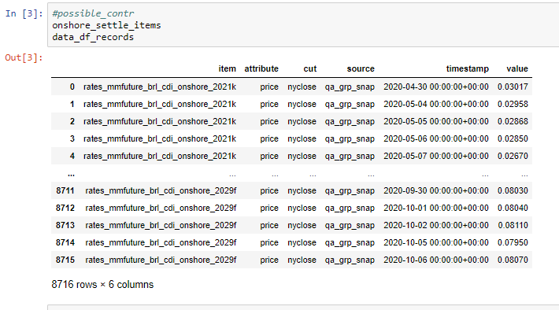

import datetime as dt

from panormus.quant.futureimport MONTH_CODE_MAP_INV

from panormus.quant.market_dateimport date_adjust

## for reference

sau_paulo_holiday_code= 'SPB'

national_holiday_code= 'SPR'

fut_code= '2020f'

def get_brl_di_futures_dates(future_code):

    year = int(future_code[0:4])

    month_code= future_code[-1].upper()

    month_num= MONTH_CODE_MAP_INV[month_code]

    first_cal_day= dt.date(year, month_num, 1)

    final_trade_date= date_adjust(first_cal_day, -1, 'D', hol_cal_name='SPB')

    contract_valuation_date= date_adjust(final_trade_date, 1, 'D', hol_cal_name='SPB')

    return {'final_trade_date': final_trade_date, 'contract_value_date': contract_valuation_date}

print(get_brl_di_futures_dates(fut_code))

